About CosmicVolt

CosmicVolt was started with a vision to deliver sustainable energy solutions for all with Solar Energy as our main focus.

We believe in conserving energy and generating energy via alternative sources.

At CosmicVolt, we promote “thinking” about Eco-Friendly and Energy Efficient alternatives Some of our key focus areas include Solar energy solutions along with energy efficiency solutions and products, waste management, solar solutions for roof tops (off /on-grid), solar pumps for institutions & industries and project management services amongst other.

Our holistic approach to sustainability and close interactions with various stakeholders makes sure that our solutions are robust, reliable and cost effective. . We also undertake preparation of detailed roadmap for CSR related activities. We have an experienced team who has worked with reputed inverter manufacturers, Solar EPCs and leading IT companies.

In addition, CosmicVolt has an advisory team with strong technical and management skills.

Our Strength:-

1.Customized Designs

2. Quality of Installation

3. Safety

4. Mounting structures for each type of Roof

5. SolarCare- Specifically for O&M purposes

6. Holistic approach to sustainability

On Grid System – Basics

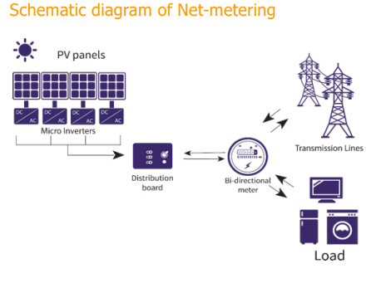

Salient features of Net Metering in Karnataka:

• The power generated from solar plant is self consumed in the building first and only the excess is exported to the grid

• A bi-directional meter will replace the existing BESCOM meter which will measure both import and export.

• While taking the monthly bill, a difference of export and import will be calculated and the payment is based on the net amount.

• If the export is more than import, BESCOM will pay the consumer for the net export. If import is more, consumer has to pay the BESCOM for the net import as per the prevailing slab rates.

• The revenue for solar energy would be deposited in the account details provided on a monthly basis.

• A PPA(power purchase agreement) will be signed between the consumer and the BESCOM for a period of 25 years.

On-Grid System with Micro-Inverters

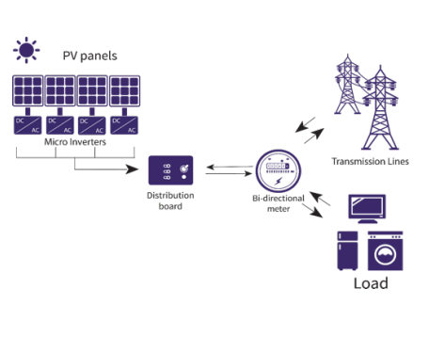

Enphase Micro inverter PV System:

• Each Panel is connected to one Micro-Inverter.

• Each panel is independent on each other for its generation.

• Shadow issues, dust accumulation, bird droppings, on one panel will not effect the whole generation of the system

• These inverters are connected in parallel. It avoids building up of high voltages

• High DC voltages are avoided

• Each inverter has inbuilt MPPT in it.

• Modules mismatch will not effect the generation of whole system

• Panel level monitoring is possible

• Longer Life, hassle free, simple installation

Enphase Energy Micro Inverters

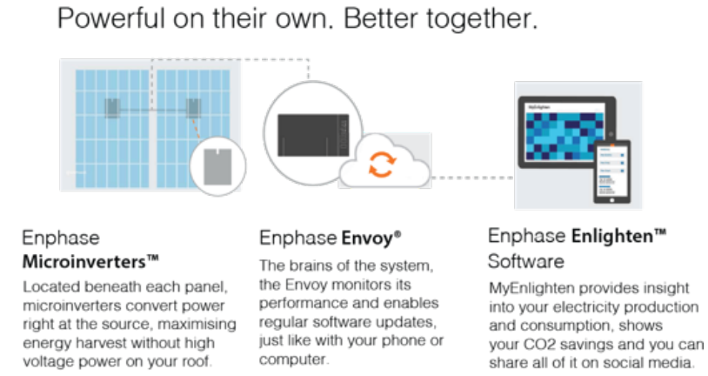

|  |  |  |
| --- | --- | --- |
| Sl No | Description |  |
| 01 | Name of the meter holder |  |
| 02 | Load Capacity for your Meter |  |
| 03 | Meter No |  |
| 04 | Address  Phone:- |  |
| 05 | Monthly Consumption |  |
| 06 | Type of Connection  **( GRID / OFF GRID )** |  |
| 07 | Self Finance / Loan |  |
| 08 | Date |  |
| 09 | CosmicVolt Represented by |  |

Price details –…………………… kWp On-Grid system with Micro-Inverters

|  |  |
| --- | --- |
| **Description** | **Cost** |
| Solar Panel: …………………………………………………………………………………….,  Micro – Inverters:- IQ7+,  Enphase Accessories – Qcable, YCable, Envoy,  Mounting Structures: Flat Roof with Ballast & Aluminium Structures  AC / DC Cabling,  AC / DC Electrical Accessories,  AC / DC Earthing, |  |
| Installation Services |  |
| Transportation |  |
| BESCOM Liaisoning & Meter Charges |  |
| Sub Total |  |
| Tax amount |  |
| Total |  |

|  |  |
| --- | --- |
| Solar Panels:- | ----- Wp Mono Crytalline Modules from _______________ – German Technology based |
| Inverters | IQ7+ Enphase micro Inverters from Enphase |
| Monitoring System | 25 Years free Online Monitoring |
| Electrical Accessories Kit Includes | Enphase Engage Cable, Array Junction Box, Array fuse plus fuse holder, MC4 Panel connectors, UPVC pipes, Junction box glands |
| Mounting Structure Includes | C-Channel, T clamps, SS bolts, Z Clamp + Square Bolts + Nuts + SS Bolts), etc. |
| Earthing Kit Includes | Earthing Kit - IS 3043:1987, 8mm dia Aluminium Down conductor, OBO Multi clamps (8mm), OBO multi clamp nails (8mm). |

Please note that the On-Grid rooftop system will not generate power if the Grid connection is not available

Terms and Conditions

|  |  |
| --- | --- |
| GST for supply of materials | 18% Taxes for 70% of Gross System Value and 18% taxes for 30% of Gross System Value |
| Packing and forwarding | Included, Single point Delivery |
| Freight charges | Included at Site |
| Entry Tax | Extra at actual, if applicable |
| Payment Terms | 30% advance against P.O for processing approvals, 60% against PPA approval and for procurement of materials, against Material delivery and Installation, 10% against BESCOM commissioning of the system (Final Bill Settlement) |
| Delivery | Within 4 weeks from the date of PO with advance. |
| Validity | 15 days from the date of offer (Estimation), any further extension will be with written communication from us. |
| Schedule | Installation within 10 weeks (subject to site readiness and scope of work and BESCOM approvals) |

Scope of Work:

• Design, procurement of above-mentioned materials, installation and testing of above mentioned on-grid system. Our scope is up to the inverter AC interconnection point.

• Installation of Solar modules for above mentioned system and Installation of Grid-tied Micro Inverter

• Supply and Installation of the Aluminum mounting structures with clamps.

• Supply and Installation of Junction boxes and Earthing kit.

• Designing of the Structure and Panel Layout

• CosmicVolt Solar reserves the right to choose an equivalent make based upon the availability of the material at the time of delivery and our assessment during detailed engineering.

Owner’s Scope:

• Providing shadow free area for Installation with safe access for material handling and Installation work

• Providing support for all the necessary approvals for installation and commissioning from any Govt. agency(if needed)

• Any roof reinforcement or development work required for the roof

• All construction related permits, approvals and licenses. Power and water for construction

• Right of Way(if applicable)- To be arranged by the ‘customer’ for delivery locations situated in Permit areas. Orders and delivery commitments are subject to receipt of Road Permits well in advance.

Warranty:

All equipment supplied by us carry original equipment warranty terms.

**Modules will have 10 years standard product warranty (modules with total 25-year performance warranty – 20% power fall limit at the end of 25th year). Enphase inverters come with 10 years of manufacturers Warranty**.

All other equipment vendors give only 12 months warranty, which will be passed on to you. Our Warranties are not valid for any mishandling, abused wear and tear, sabotage/force majeure conditions.

Permits and approvals required are given below:

* Interconnection permission from your power distribution agency (DISCOM)
* CEIG’s (Chief Electrical Inspector to the Government of state) permission (pre & post-installation) as applicable. (in case of 10kW and above)

Permission and Approval process for grid-connected system under Net Metering :

* Submission of application to the local distribution company (DISCOM) with project details and required permit fee.
* The distribution company will conduct a feasibility analysis of the Project Site. Distribution Company will approve or reject the proposal based on the report.
* After the distribution company (DISCOM) approval, an application is to be submitted to the DISCOM for registration of the rooftop project.
* Interconnection agreement is signed by the consumer and the DISCOM.

Liaising and facilitation for net metering will be executed by Cosmic-Volt team. However, one-time fee for commissioning net meter may come in customer’s scope (which would be charged as per the DISCOM policies for different states).

Dedicated Customer Support



We assign you an Account Manager who’ll help you with all servicing and support needs.

We believe in delighting the customer and have dedicated, responsive customer support for all your information, performance and breakdown needs. We are happy to help in all phases of your solar journey, from inquiry to solar plant’s entire life. Our customer support team is inculcated with values which include:

* Quick resolution of queries and system breakdown, Empowering the customer through information, Minimizing the system downtime
* Hassle free warranty management

If you are planning to install a solar plant and have any queries, feel free to call us on our number 9448649530 or contact your sales representative. If you have Cosmic-Volt installed, you can contact our customer care through our mobile app, email us on CosmicVolt.com@gmail.com or call us on the dedicated number shared with you on installation.

Maintenance Services

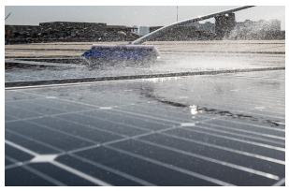

We ensure a worry-free ownership of every CosmicVolt through our dedicated support and comprehensive Maintenance Packages. Our Maintenance Packages are curated with assorted services and are available in varying durations.

01

**System Checking:** Our expert maintenance team conducts periodic visits to ensure proper functioning of the CosmicVolt – from checking the inverter, connections, earthing to deep cleaning the modules.

02

**Predictive & Preventive Maintenance:** CosmicVolt ’s proprietary remote monitoring system, also available to you through our mobile app, can detect any anomaly in the system to predict and prevent any system downtime.

03

**Breakdown Maintenance:** In case of any system breakdown/malfunction, you can contact our dedicated customer support to identify the problem and resolve it at the earliest.

04

**Replacement of Spare & Consumables:** Our inventory has comprehensive collection of the spare parts and consumables available to replace quickly, minimizing the system downtime.

05

**Warranty Management:** We provide the best-in-class warranty on all system components. In case anything malfunctions, you just have to contact us, not run to the manufacturer.

06

**Account Manager:** We assign a dedicated Account Manager you can contact to resolve your queries and attend all your services and breakdown needs.

07

**Product Insurance:** We offer **optional** product insurance in our AMC packages to protect your system against fire, natural calamity etc.

Thank You.